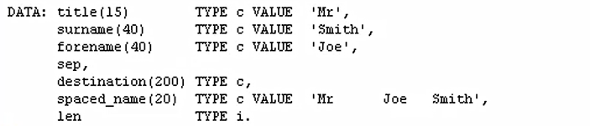

So the first thing to do, is to declare the new data field. We'll call it LEN for length, and the data type of I just to hold the integer value that will represent the length of the string you're trying to interrogate.

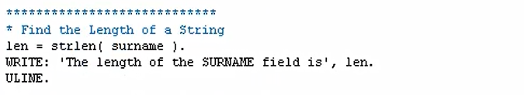Then down to the code, we can have the following three lines, and you'll see it looks very simply, we have the field we have just defined and that will contain the length of the surname field. And it is this string function, the string length function, strlen, that will look at the surname field, move the length of the string into the LEN field we've declared.



If we take a quick peek at the surname field. You can see it currently holds the word Smith. Which is five characters in length. So when we execute this report the LEN field will contain the number five. And that will be output at the end of this write statement.